BLANK PAGE
Total marks (84)
Attempt questions 1 – 7
All questions are of equal value

Answer each question in a SEPARATE writing booklet. Extra writing booklets are available.
________________________________________________________________________

Marks

2

2

2

2

2

2

Question 1 (12 Marks) Use a SEPARATE Writing Booklet.

(a) Find 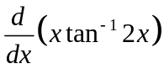

(b) The parametric equations of a curve are given by 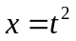, 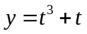.
Find the Cartesian equation of the curve (that is y in terms of x).

(c) Write down the general solution of 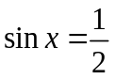.

(d) The interval AB has end points A (5, 4) and B (x, y). The point P ( −1, 3) divides AB internally in the ratio 2:3. Find the coordinates of B.

(e) Evaluate 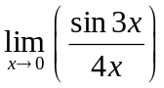.

(f) Use the table of standard integrals to find the exact value of

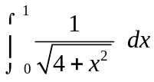

Question 2 (12 Marks) Use a SEPARATE Writing Booklet.
Marks

2

3

4

2

1

(a) Find, correct to the nearest degree, the obtuse angle between the lines
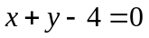 and 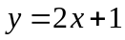.

(b) Solve 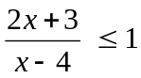.

(c) Use the substitution 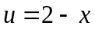 to evaluate 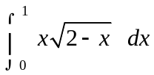.

(d) (i) Write down the domain and range of the function 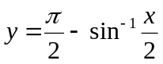.

(ii) Hence sketch the function.

.

Question 3 (12 Marks) Use a SEPARATE Writing Booklet.

Marks

3

2

2

1

2

2

(a) Find the exact value of 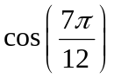in simplest surd form, with a rational denominator.

y
(b)

2
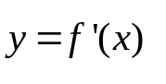

x
-2

The diagram above shows a sketch of the gradient function of the curve y=f(x).

Copy this diagram into your writing booklet.

On the same diagram, draw a possible sketch of the function y=f(x), given that f(0)=3 and 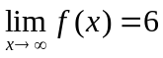.

(c) Consider the point 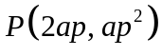 on the parabola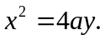

Show that the equation of the normal to the parabola 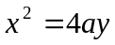 at the

point P is given by 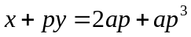.

Find the equation of the line which passes through the focus S(0, a) and

is perpendicular to the normal.

If the line found in part (ii) meets the normal at N, find the coordinates

of N.

Show that the locus of N is a parabola and find its vertex.

Question 4 (12 Marks) Use a SEPARATE Writing Booklet.
Marks

2

1

2

2

1

2

2

(a) Determine the exact value of 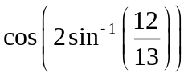.

(b) (i) Show that the equation 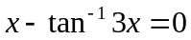 has a root lying between x = 1
and x = 2.

(ii) By taking.5 as an initial approximation to the root of , in the interval 1 < x < 2, use one application of Newton's method to find a second approximation to this root.

(c) The velocity of a particle moving in a straight line is given by

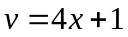,

where x is the displacement (in metres) from a fixed point 0, and v is the velocity in metres per second.

Find the acceleration of the particle when it is 5 metres to the right of the origin.

(d) Newton's law of cooling states that the rate of cooling of a body is proportional to the excess of the temperature of a body above the surrounding room temperature. The temperature of a cup of chocolate drink satisfies an equation of the form 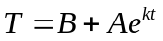 where T is the temperature of the drink, t is time in minutes, A and k are constants and B is the temperature of the surroundings.

The drink cools from 85°C to 70°C in three minutes in a room of temperature of 22°C.

Find the value of A.

Find the value of k, correct to 3 decimal places.

(iii) Find the temperature of the cup of chocolate, to the nearest degree, after a further 9 minutes have passed.

Question 5 (12 Marks) Use a SEPARATE Writing Booklet.
Marks

1

1

2

1

3

4

(a) Suppose 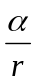, α and are the real roots of the cubic equation 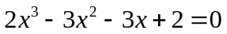.

(i) Write down the value of the sum of all three roots.

(ii) Write down the value of the product of all three roots.

- Deduce that r can take on two real non-zero values and find them.

(b) Anna (A) is standing due south of Phillip (P) who is assisting an injured bush walker. A rescue helicopter (H) is hovering directly over P and lowering a stretcher. Anna measures the angle of elevation of the helicopter to be 60° from her position. Belinda (B) is 1 kilometre due east of A and measures the angle of elevation of the helicopter to be 30°. The height of the helicopter above P is x metres.

H

NOT TO SCALE
x

P
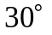
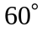

A
1 km

B

South

Write expressions for both AP and BP in terms of x.

Hence or otherwise find the height of the helicopter correct to the

nearest 10 m.

(c) Use the Principle of Mathematical Induction to show that 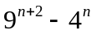 is
divisible by 5 for all positive integers n.

Question 6 (12 Marks) Use a SEPARATE Writing Booklet.
Marks

2

3

2

(a) (i) State the domain and range for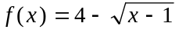.

(ii) Find the inverse function 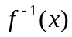and state the domain and range for which it exists.

(iii) Sketch the graph of and its inverse function on the same number plane.

5

(b)
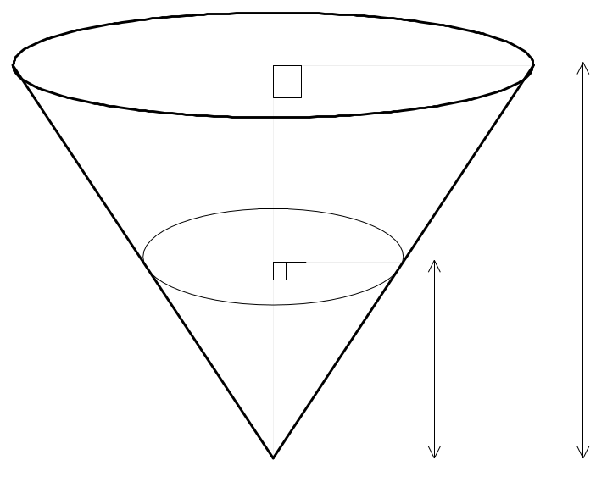
h
10
8 m
r

NOT TO SCALE

A bulk container for emptying grain into rail trucks is in the shape of an inverted cone with base radius 8 metres and height 10 metres. The grain is released from the apex of the cone at a constant rate of 35 m³/s. The depth of grain in the container at any given time is h metres and the radius of the circle formed by the top of the grain at that same time is r metres.

If the grain is released continuously until the container is empty, calculate the rate at which the radius (r) is decreasing when the depth (h) is 0.65 metres.

Question 7 (12 Marks) Use a SEPARATE Writing Booklet.
Marks

4

4

3

1

(a) By using the t – method (that is, let 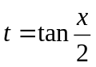) solve the equation

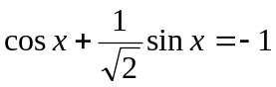,

for x such that 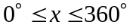

(b) Find the volume of the solid formed by rotating about the x axis, the region bounded by 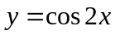, the x axis, from x = 0 to 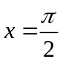.

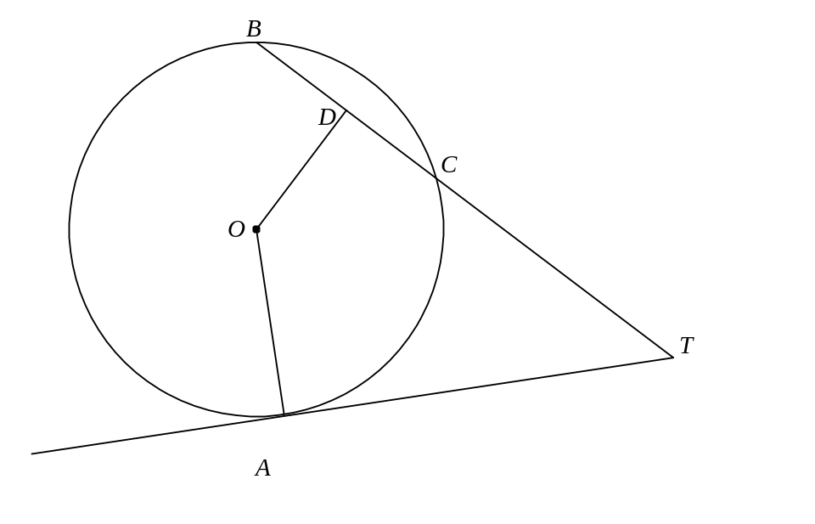
(c)
NOT TO SCALE

In the diagram above A, B and C are three points on a circle, centre O. The tangent at A meets BC produced at T. D is the midpoint of BC.

Copy this diagram into your writing booklet.

- Prove that AODT is a cyclic quadrilateral.

(ii) Explain why 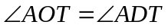.

End of Paper

BLANK PAGE

STANDARD INTEGRALS

